Vehicle health characteristics

**Car coolant**, also known as antifreeze, protects engines from overheating. **Coolant** also lubricates the moving parts it comes into contact with, which protects damage to the water pump, head gasket, the cylinder and piston timing.

It's the job of the exhaust and cooling system to make sure the engine stays cool. The **coolant** absorbs the heat from the engine and stops the engine water from boiling in the summer. In addition, it also ensures metal parts don't rust and rubber or plastic parts don't corrode.

**Damage** accumulation in materials is a consequence of micro-defect evolution, which may lead to degradation of mechanical properties up to failure.

Data is obtained from the OBD-II device which is integrated with the vehicle and from some inbuilt sensors present in the car engine temperature, tyre pressure, engine oil level. This data represents the important data needed for the estimation of the safety of a vehicle.

K-nearest neighbor algorithm stores all available cases and classifies new cases based on similarity measures. Here binary classification can be applied to classify the data and predict whether the condition of the vehicle is safe or not.

**Fuel consumption** is the rate at which an engine uses **fuel**, expressed in units such as miles per gallon or liters per kilometer. Engine designers strive for **more** power, lower **fuel consumption**, lighter weight, and better reliability.

This bad habit is threefold – driving **too** fast, accelerating **too** quickly, and stopping **too** suddenly. All three of these actions lead to **high fuel consumption**. Where possible, you should accelerate slowly and drive with the speed of traffic.

Running an **engine** on old, sludgy **oil** will cause a decrease in **fuel economy**. ... Without the right viscosity, the **oil** loses the essential ability to get where it needs to go in the **engine**. The **engine** runs hotter and less efficiently, robbing the **engine** of both **gas mileage** AND horsepower. Regular **oil changes improve** your car's **gas mileage** as fresh **oil better** moves through the engine, clears out sludge on components and in passages, **better** lubricates metal parts reducing heat and friction and helps the engine generally run more efficiently with less work, so it doesn't eat up as much **gas.**

There are three basic types of suspension **components**: linkages, **springs**, and **shock absorbers**. The linkages are the bars and brackets that support the wheels, **springs** and **shock absorbers**. **Springs** cushion the vehicle by dampening shock loads from bumps and holes in the road.

The **suspension system** on a **vehicle** is between the frame and the road. The **suspension system's** primary function is to maximize the overall performance of a **vehicle** as it cruises down the road. The **suspension system** also helps to absorb bumps in the road and provide a safe and comfortable ride. A transient vibration is one that dies away with time due to energy dissipation. Usually, there is some initial disturbance and following this the system vibrates without any further input.

Torque at engine and at wheels

Difference in theoretical and calculated value should be within permissible limit.

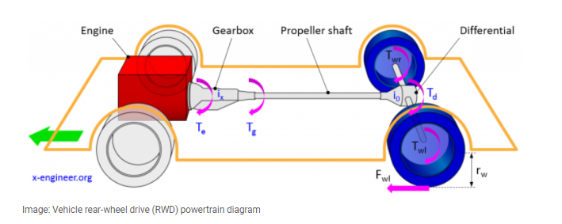

The gearbox is connected to the engine through the clutch. We consider that there I absolutely no slip in the clutch, then the engine torque Te is equal to clutch torque Tc.

Tc = Te

Further, the engine torque is transmitted through the gearbox, where is multiplied with gear ratio of the engaged gear ix and outputs the gearbox torque Tg.

Tg = ix * Te

The propeller shaft is transmitting the torque to the rear axle, where is multiplied with the final gear drive ratio io. This gives torque at differential Td.

Td = io * Tg

If the vehicle is driven on straight line, the torque at the differential is equally split between the left and right wheel.

Tlw = Trw = Td / 2

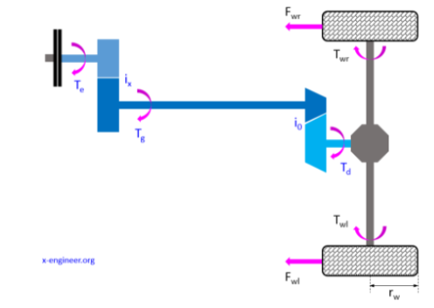

Tw = (Ix * Io * Te) / 2

We calculate wheel torque (Tw) by above formula, and we get the engine torque from car engine specification.

Tw = ((Ix * Io * Te) / 2) * 0.85

So, we have theoretical value of wheel and real-time value from OBD data.

Difference between them will tell us about the health of the transmission system.

Engine Load

Load is an important factor for the vehicle operation. “Load” means how much power is required from the engine for the car to have some speed and acceleration.

Fuel Consumption

Fuel consumption is the amount of fuel used per unit distance. (liters per 100 kms), the **lower** the value, the more economical a vehicle is (the less fuel it needs to travel a certain distance).

$$Fuel flow=\frac{Fuel \left(\frac{g}{s}\right)* 360}{⍴}$$

Fuel (g/s) this values we will get from OBD data.

To calculate fuel consumption at l/100 km:

$$Fuel consumption=\frac{Fuel Flow *100}{Vehicle speed}$$

The power of the vehicle engine can be controlled by changing the air-fuel ratio of the engine which is done by constrictions of the Throttle. The speed of the engine can be controlled by varying the amount of fuel and air supplied to the engine.

The Oxygen O2 sensor is located in your vehicle's exhaust system, usually on the exhaust manifold or close to the engine. There may be several oxygen sensors on your vehicle.